**Day3**

**1.)%{**

**int nlines,nwords,nchars;**

**%}**

**%%**

**\n {**

**nchars++;nlines++;**

**}**

**[^\n\t]+ {nwords++,nchars=nchars+yyleng;}**

**. {nchars++;}**

**%%**

**int yywrap(void){}**

**int main()**

**{**

**yylex();**

**printf("Lines=%d\nChars=%d\nWords=%d",nlines,nchars,nwords);**

**return 0;**

**}**

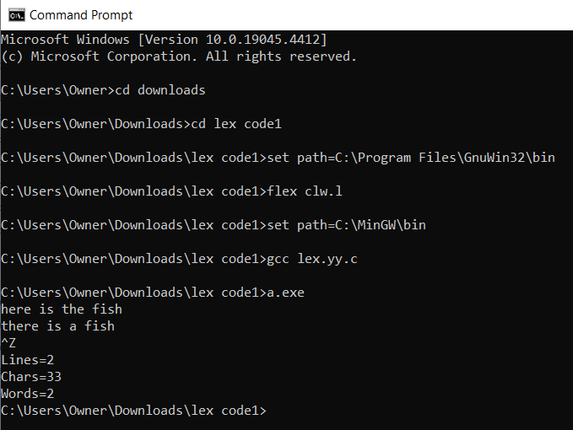

**2.)%{**

**int nmacro,nheader;**

**%}**

**%%**

**^#define {nmacro++;}**

**^#include {nheader++;}**

**%%**

**int yywrap()**

**{**

**return 1;**

**}**

**int main()**

**{**

**yylex();**

**printf("NUmber of macros defined=%d\n",nmacro);**

**printf("NUmber of header files included=%d\n",nheader);**

**}**

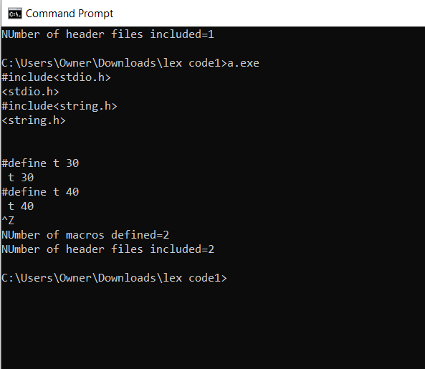

**3.)**

**%{**

**%}**

**%%**

**<INITIAL>[0-9]+ {printf("integer\n");}**

**<INITIAL>[0-9]+[.][0-9]+ {printf("float\n");}**

**<INITIAL>[A-Za-z0-9_]* {printf("identifier\n");}**

**<INITIAL>[^\n] {printf("invalid\n");}**

**%%**

**int yywrap(){}**

**int main()**

**{**

**printf("enter String\n");**

**yylex();**

**return 0;**

**}**

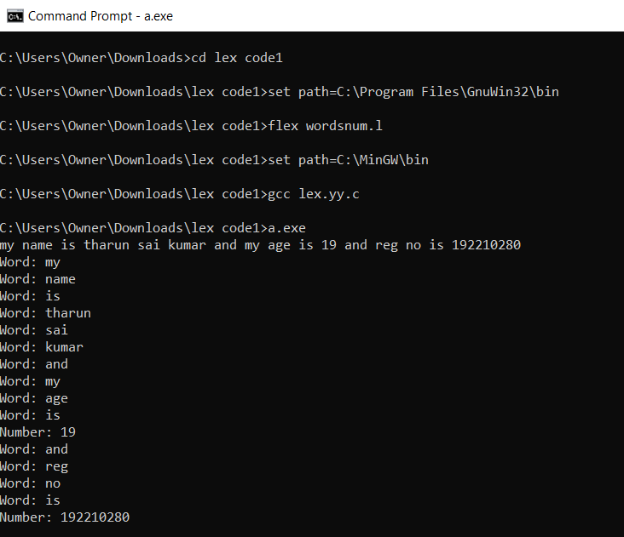

**4.)%{**

**int ln=0;**

**%}**

**%%**

**.* {ln++; fprintf(yyout,"\n%d:%s",ln,yytext);}**

**%%**

**int yywrap(){}**

**int main()**

**{**

**yyin=fopen("simple1.txt","r");**

**yyout=fopen("out.txt","w");**

**yylex();**

**}**

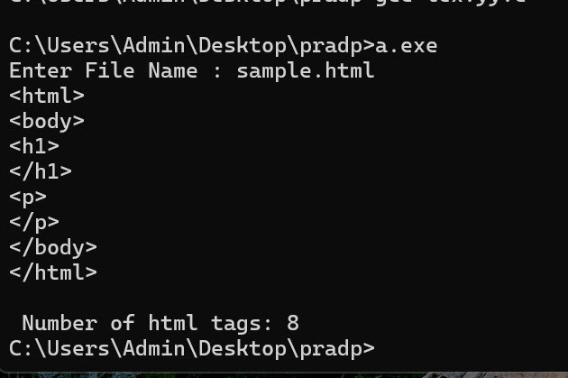

**5.)%{**

**int vow_count=0;**

**int const_count=0;**

**%}**

**%%**

**[aeiouAEIOU] {vow_count++;}**

**[a-zA-Z] {const_count++;}**

**%%**

**int yywrap(){}**

**int main()**

**{**

**printf("enter the string of vowels and consonents:");**

**yylex();**

**printf("number of vowels are:%d\n",vow_count);**

**printf("number of consonents are:%d\n",const_count);**

**return 0;**

**}**

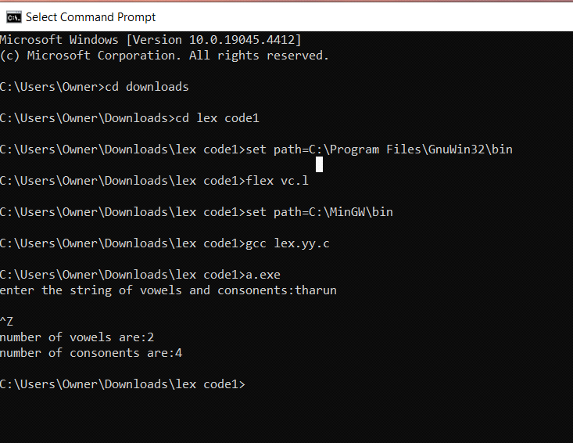

**6.)%{**

**%}**

**%%**

**[a-zA-Z][a-zA-Z0-9]+ {printf("\n is identifier",yytext);}**

**.+ {printf("\n%s is Keyword",yytext);}**

**%%**

**int yywrap(){}**

**int main()**

**{**

**printf("Enter the input:");**

**yylex();**

**}**

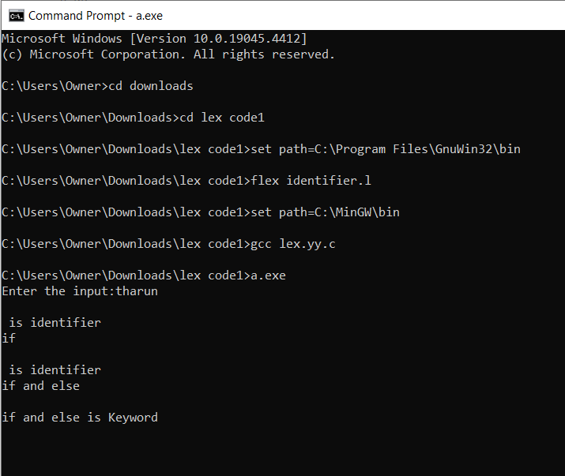

**7.)%{**

**int ln=0;**

**%}**

**%%**

**.* {ln++; fprintf(yyout,"\n%d:%s",ln,yytext);}**

**%%**

**int yywrap(){}**

**int main()**

**{**

**yyin=fopen("simple1.txt","r");**

**yyout=fopen("out.txt","w");**

**yylex();**

**}**

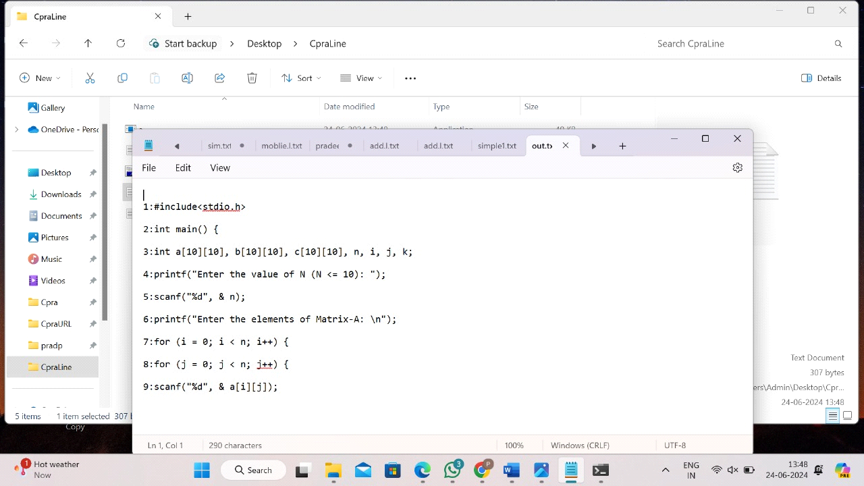

**8.)%{**

**#include <stdio.h>**

**#include <ctype.h>**

**%}**

**%%**

**[A-Za-z]+ { printf("Word: %s\n", yytext); }**

**"==" { printf("Relational Operator: %s\n", yytext); }**

**"!=" { printf("Relational Operator: %s\n", yytext); }**

**"<=" { printf("Relational Operator: %s\n", yytext); }**

**">=" { printf("Relational Operator: %s\n", yytext); }**

**"<" { printf("Relational Operator: %s\n", yytext); }**

**">" { printf("Relational Operator: %s\n", yytext); }**

**[ \t\n]+ { /* ignore whitespace */ }**

**. { /* ignore other characters */ }**

**%%**

**int yywrap() {**

**return 1;**

**}**

**int main() {**

**yylex();**

**return 0;**

**}**

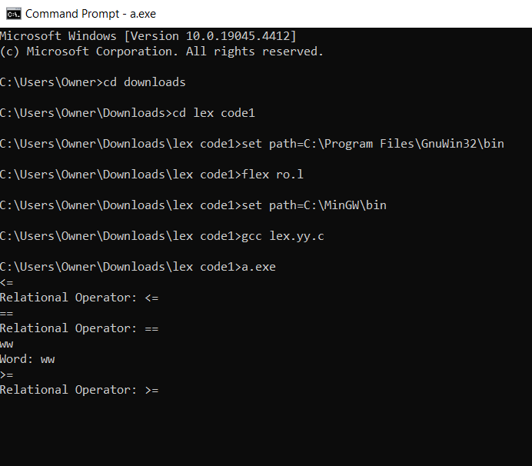

**9.)**